Title (20 point, Times New Roman, Bold)

Firstname Lastname1, Firstname Lastname1 and Firstname Lastname2 (12 point, Times New Roman)

1*University Department, University Name, City, State Zip code, Country*

2*University Department, University Name, City, State Zip code, Country*

*(11 point, Times New Roman, Italic)*

**Keywords:** aaaa, bbb, ccc, ddd

Body of abstract ……. An abstract length is 2 pages. Use 11 point Times New Roman font in the body. All references, figures, tables and equations should be cited consecutively in numerical order [1-2].

The caption for a figure appears below the graphic; for a table, above. Figure 1 and Table 1 are samples.

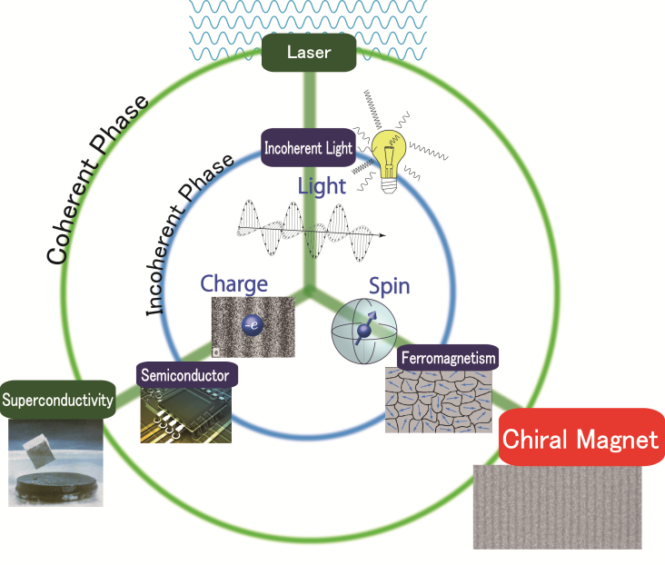

Figure 1. Sample figure



Table 1. Sample table (11 point, Times New Roman, Bold)

Fonts should be embedded when you create the PDF.

# References (14 point, Times New Roman, Bold)

[1] J. Kishine, K. Inoue, and Y. Yoshida: Prog. Theor. Phys. Suppl. 159 (2005) 82.

[2] J. Kishine, I. Proskurin, and A. Ovchinnikov: Phys. Rev. Lett.107 (2011) 017205.

(11 point, Times New Roman)